Summary of Preamplifier Development

To amplify the echo received by the 5 MHz transducer, it was necessary to implement an amplifier that would allow for proper analysis of the signal. Research was carried out to identify the most suitable operational amplifier (OpAmp), with preference given to a model that would introduce minimal noise, provide a sufficiently high bandwidth given the signal operates at 5 MHz and offer variable gain.
This represented the first major challenge. After reviewing several datasheets, the AD8038 was identified as the most appropriate choice for the project. During the assembly of the circuit using this OpAmp, guidance was sought from Professor Telmo Cunha. With his assistance, two diodes were added to limit the input voltage and protect the component from damage. Additionally, a capacitor was included to remove the DC component of the signal, as illustrated in Figure 1.

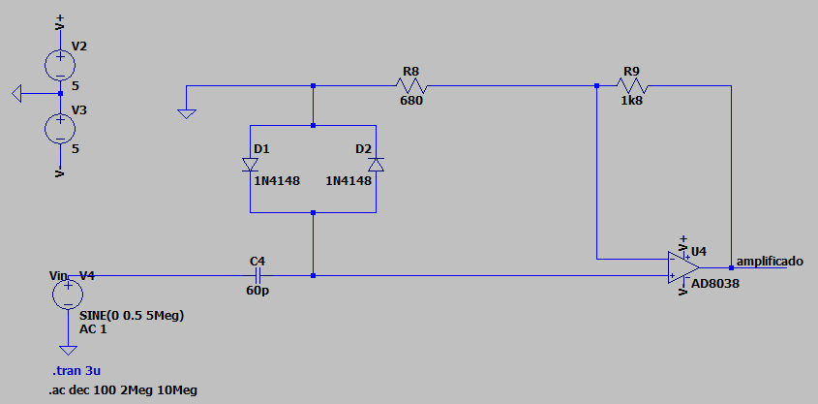
Figura 1 - Preamplifier Circuit, LTspice

Later, when assembling the circuit on a breadboard, a new obstacle emerged: the component acquired was not available in a format compatible with the test board (DIP), making direct testing in this configuration impossible. To overcome this limitation, Engineer Manuel Arez provided a custom PCB for the OpAmp, as shown in Figure 3, which enabled isolated testing.
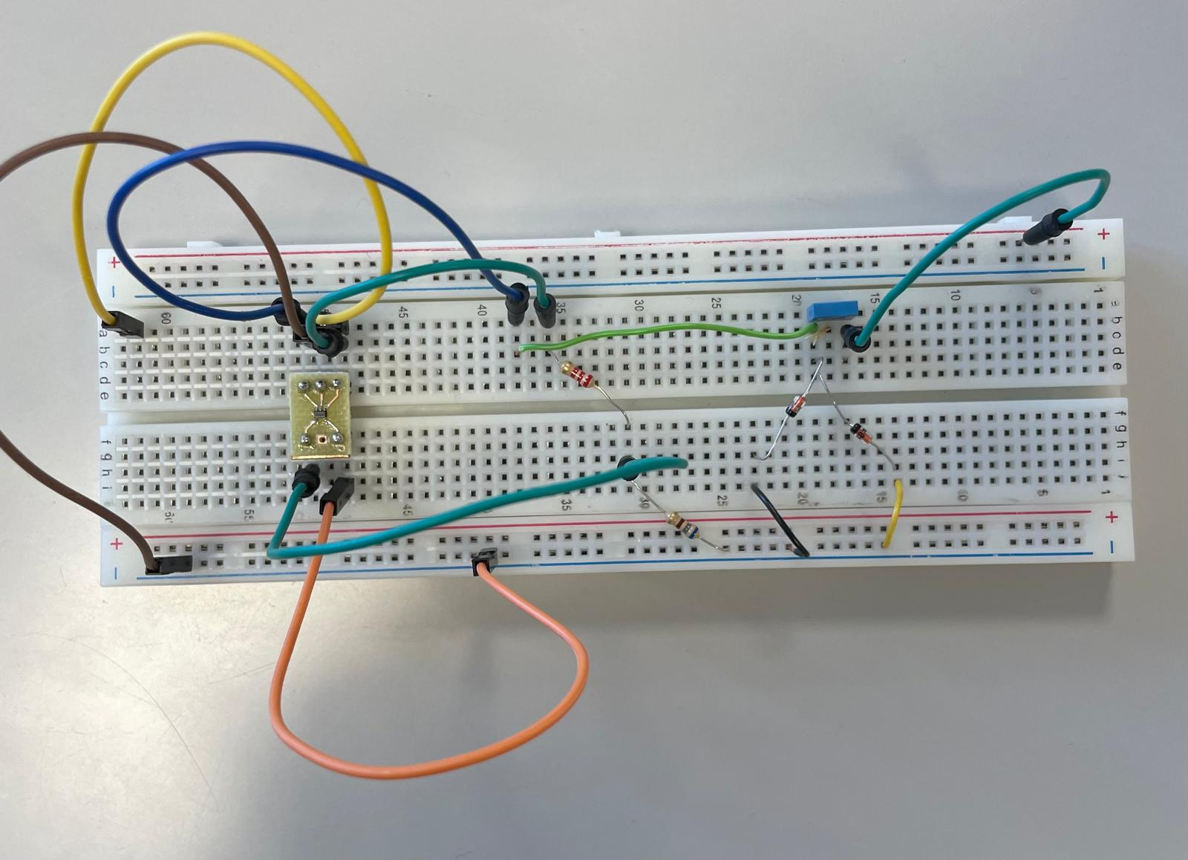
Figura 2 - Preamplifier Circuit, Breadboard

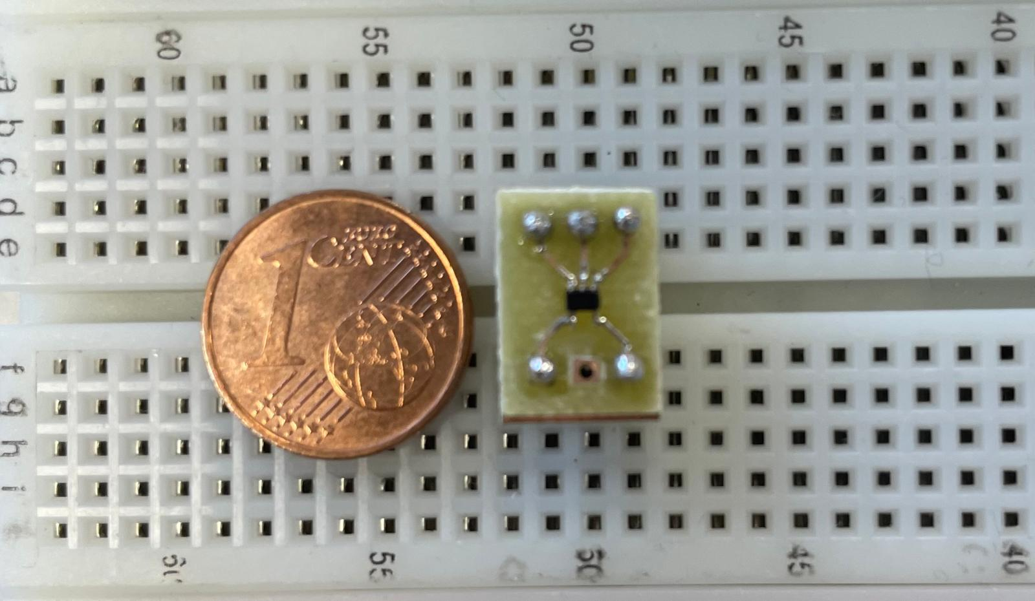

Figura 3 - PCB for AD8038 Integration

As shown in Figure 4, the initial tests indicated that the circuit was functioning as expected. However, after several additional trials, the OpAmp experienced a short circuit due to solder bridging between the terminals. This fault prevented further testing with the transducer, as was originally planned.

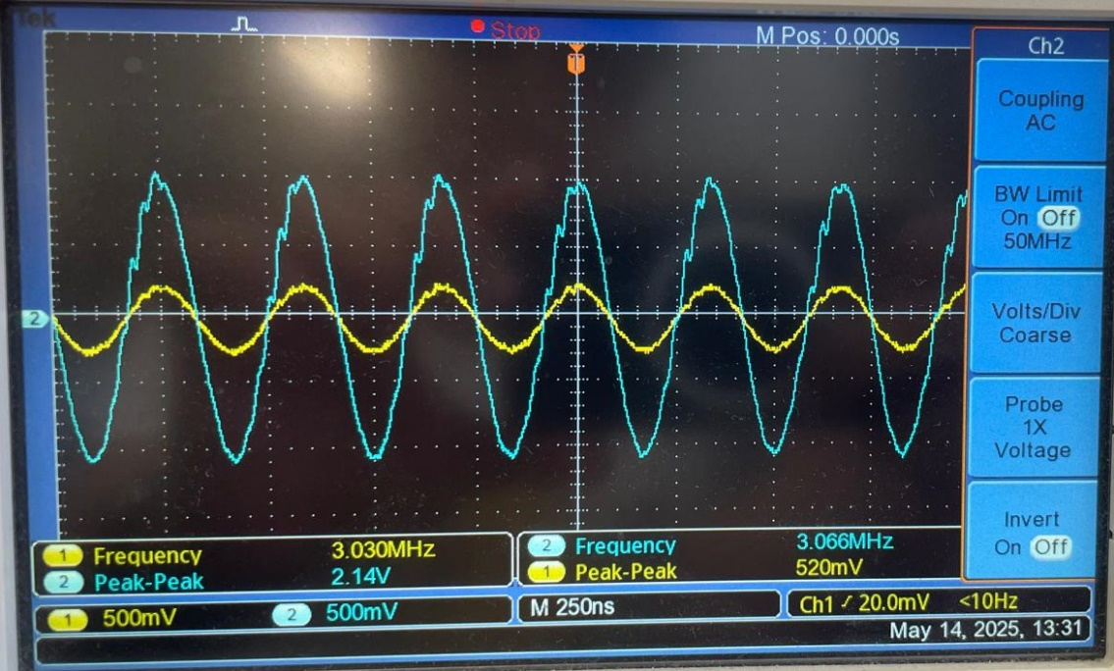
Figura 4 - Preamplifier Output, Oscilloscope
- Theoretical Gain
$$A_{v}=1+\frac{R_{2}}{R_{1}}=3.64 V/V$$

- Practical Gain
$$A_{v}=\frac{V_{out}}{V_{in}}≈3.96 V/V$$

As can be observed, the practical gain is close to the intended theoretical value. Thus, it can be concluded that the circuit performs as designed.

